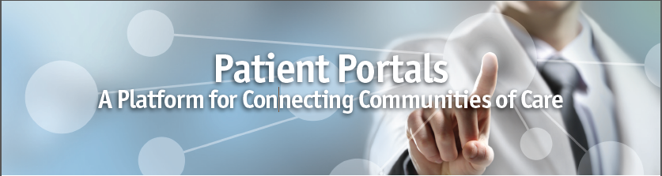Within the context of healthcare reform and meaningful use, your ability to connect patient health data across the care continuum is essential if you hope to achieve the healthcare triumvirate; *improve care, increase access, and lower costs*. While there has been a myriad of initiatives, such as state-sponsored Health Information Exchanges that have attempted to enable this connection, but business complexities have led to many of their demise.

However, we believe that a successful approach rests in having a health system that serves as the connectivity hub for bringing patients, care givers and healthcare professionals together in a secure, online environment. Hospitals, by their *de facto* nature of being the central pivot point for their community’s healthcare services, are the natural data ambassadors and with the right strategy can ascend to a position of sustained leadership in the arena of care, community connectivity and patient empowerment.

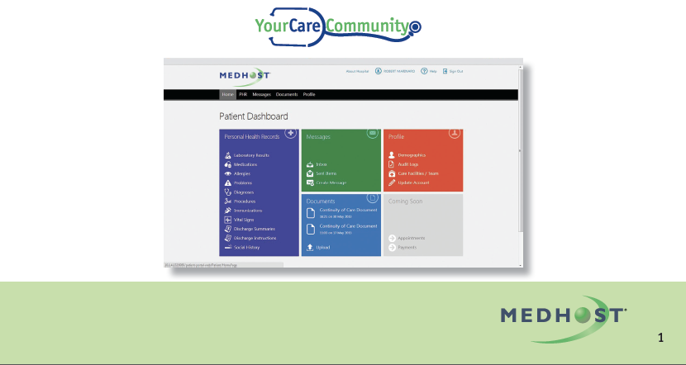Currently, patient portals are a key component in creating quick, efficient two-way communication between healthcare professionals and patients. Additionally, their design allows for secure data connectivity between care teams for all the obvious care management and outcome benefits that result from doing so. The challenge, however, is the cost, interoperability and scalability issues; that arise in integration between independently owned care setting locations and disparate EHR's that exist in the marketplace.

**Minimizing Complexity to Enhance User Experience, Engagement and Value**

A central patient portal enhances user experience allowing health systems to better realize a portal’s intended benefits by:

Enhancing efficiencies and increasing value

In most current situations, patients have different portals for each provider they may be seeing (primary care, specialist, etc.), or for each facility where they receive care (hospital, post-acute care setting, etc.). This situation requires patients to manage their healthcare information, appointment schedules and online interactions with their caregivers in multiple online environments and with different log-on procedures. As a result, most patients will opt out of such a confusing and complex process, rendering EHRs or portals fairly useful.

However, implementing a platform strategy, where the hospital or health system can serve as the central hub to connect its affiliated care network through EHR vendor-neutral portals, create an online environment where a single sign-on solution allows patients and healthcare professionals access to data regardless of where it originated within the healthcare network.

A central portal strategy is particularly valuable today as the aging demographics of our country reveal we are experiencing the largest number of people older than sixty years old that we have ever seen. Because people will

• Live longer than past generations

• Have multiple health- issues

• Be seen by multiple physicians

Creating efficient access to their health records across the care continuum is not a luxury-it is imperative.

Create care-focused communities – better enabling population health

As is well known, achieving long-term optimal health is a team effort, not an individual activity. A central portal strategy provides a more effective methodology for supporting team efforts among caregivers.

Implementing a vendor-neutral approach that allows for connectivity across the care continuum increases and improves opportunities to develop online communities that support healthcare professionals and patients in achieving optimal health. Additionally, patient portals can serve as virtual destination points for delivering personalized wellness and disease management programs to patients:

• Take, for instance, a diabetic patient in his/her mid-50’s, who works, has high school-aged children at home and is also a family caregiver for older parents. A portal that also serves as a destination point for care management provides this patient with the opportunity to receive content, review lab results, interact with other community members and connect with his/her physicians when and where it is convenient – without having to travel to a physician office.

2

We believe that digitally delivering focused content to a patient, where and when he wants it, can significantly impact:

• Increased patient usage of portals and care management or wellness programs

• Utility of data collected: additional patient usage = more data = greater value of data in support of clinical decision making

• Return on investment of wellness or care management programs by augmenting support for clinical decision making

Cottage Hospital

Our Customer, Cottage Hospital in Woodsville, NH, is realizing the value of a central patient portal strategy. The hospital is introducing its portal to inpatients who are being transferred to the hospital’s step-down unit. While in the step- down facility, patients and authorized family members can access patient medical information and physician or other caregiver instructions through available computer terminals and hospital-based kiosks. After introducing the portal to step-down unit patients, Cottage will implement its patient portal, within its primary care network – allowing primary care facilities to connect to the central portal, regardless of which EHR applications they use.

“Lastly, Cottage Hospital will enable connectivity to the portal for its entire physician network (primary care and specialists) serving the communities healthcare needs. Once this phase has been implemented, Cottage plans to utilize the system for other services such as diabetes management and medical nutritional therapy”.

To encourage use and enhance the value of its connected healthcare community, the Cottage is supporting the implementation of the centralized patient portal with a coordinated patient education program that includes:

• Physician’s office posters or signage

• Home-based materials, such as refrigerator magnets

• Follow-up direct mail

• Special events, such as an open house, where information about the portal will be on display

• Local radio announcements

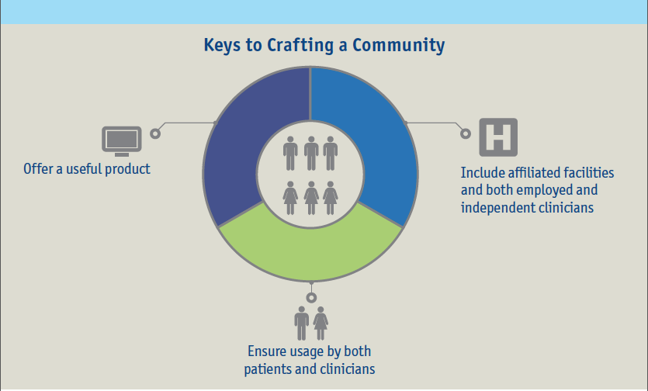

Driving Health System Growth and Community Leadership

For a health system to be sustainable in the new health care paradigm, providers must switch from episodic centered care to whole health-focused care. Data availability across the care continuum, and the ability to connect and tailor care at the clinic and patient level is vital in being whole-health focused.

*Health systems that implement a platform to connect disparate her’s among aligned healthcare providers will create market advantages that move them toward more measurable, accountable care initiatives and will better position themselves to meet the demands of the changing reimbursement environment.*

In addition, the ability to connect, store and securely shares data from virtually all EHR applications, reinforces the health system’s value in:

• Providing a cost-effective and integrated solution for physician and ancillary service providers struggling with EHR and Meaningful-Use requirements

• Targeting and communicating needed services across patience population and healthcare professional audiences

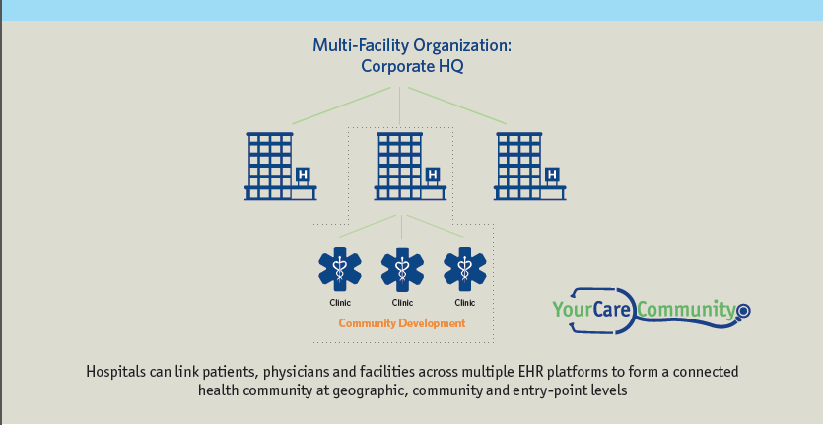

Patient Portal Platform Implementation Criteria

As your health system continues to develop its approach to connecting patients and healthcare professionals through a portal strategy. The following criteria can be useful when evaluating your options:

• **Cost of implementation**

One-to-one solutions can prove to be heavy investments in both time and cost. A platform approach should not require the high cost of one-to-one integrations.

• **Scalability**

As hospital systems grow organically and by acquisition, it is critical that your portal strategy allows connectivity with an almost finite number of practices and patients.

• **Interoperability**

With the myriad of EHR solutions available in the marketplace, your portal strategy has to be vendor-neutral, allowing for integration of any system built on industry-agreed data standards.

• **Value-added Applications**

As market needs and functionality requirements grow, your strategy should include the ability to add features that increase the value of the portal to your organization’s business development, your participating physicians and patients.

For more information and insights on constructing the right portal strategy for your organization, please contact us at: 800.383.6278 or [marketing@healthtechholdings.com.](mailto:marketing@healthtechholdings.com)

